Notification icon on the fragment
Application to refer TERADYNE-0.1_fusion_like_notification_on_Shell.zip.
Step 1:
add the things to the fragment like the action chain ,type and variables.

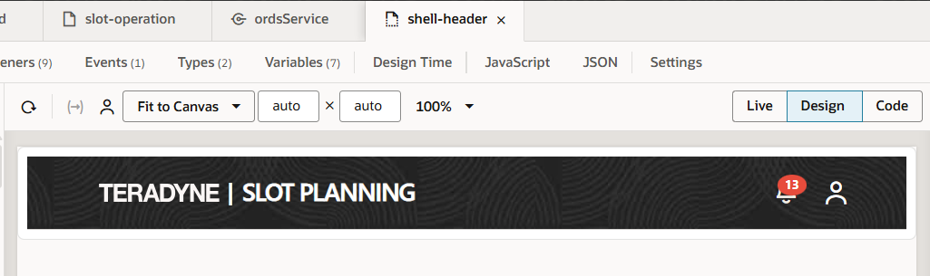
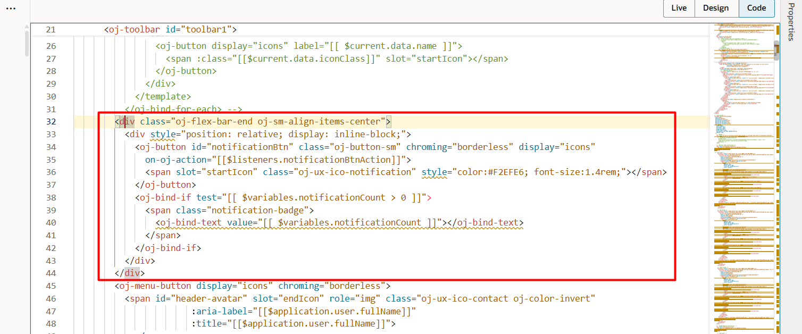
<div class="oj-flex-bar-end oj-sm-align-items-center">
<div style="position: relative; display: inline-block;">
<oj-button id="notificationBtn" class="oj-button-sm" chroming="borderless" display="icons"
on-oj-action="[[$listeners.notificationBtnAction]]">
<span slot="startIcon" class="oj-ux-ico-notification" style="color:#F2EFE6; font-size:1.4rem;"></span>
</oj-button>
<oj-bind-if test="[[ $variables.notificationCount > 0 ]]">
<span class="notification-badge">
<oj-bind-text value="[[ $variables.notificationCount ]]"></oj-bind-text>
</span>
</oj-bind-if>
</div>
</div>

Popup:
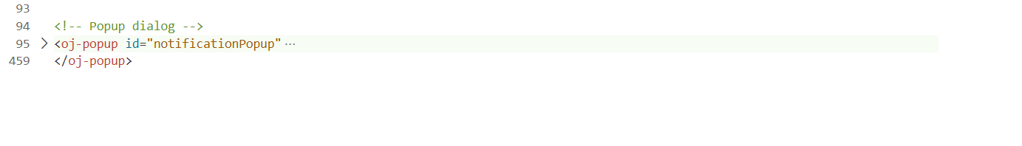
Action chain with its event listener:
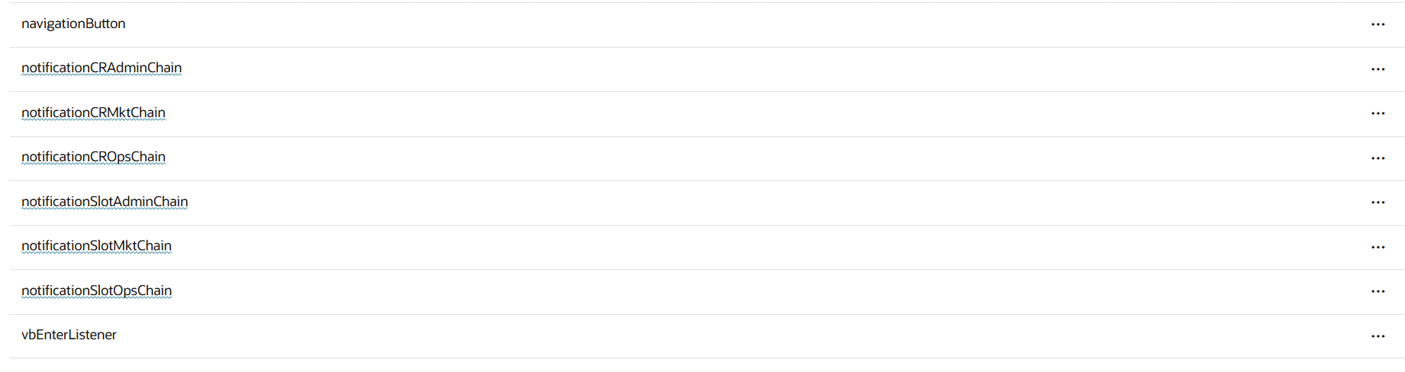
type :
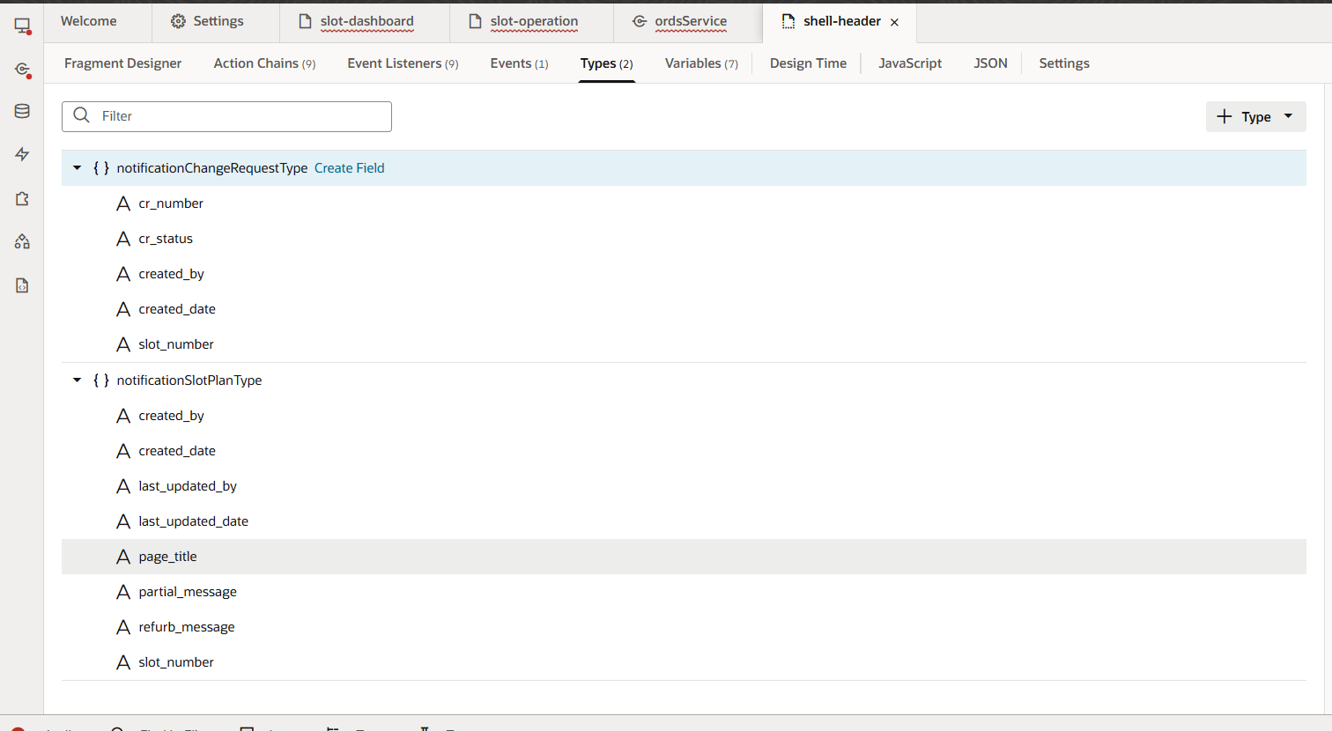
variable:
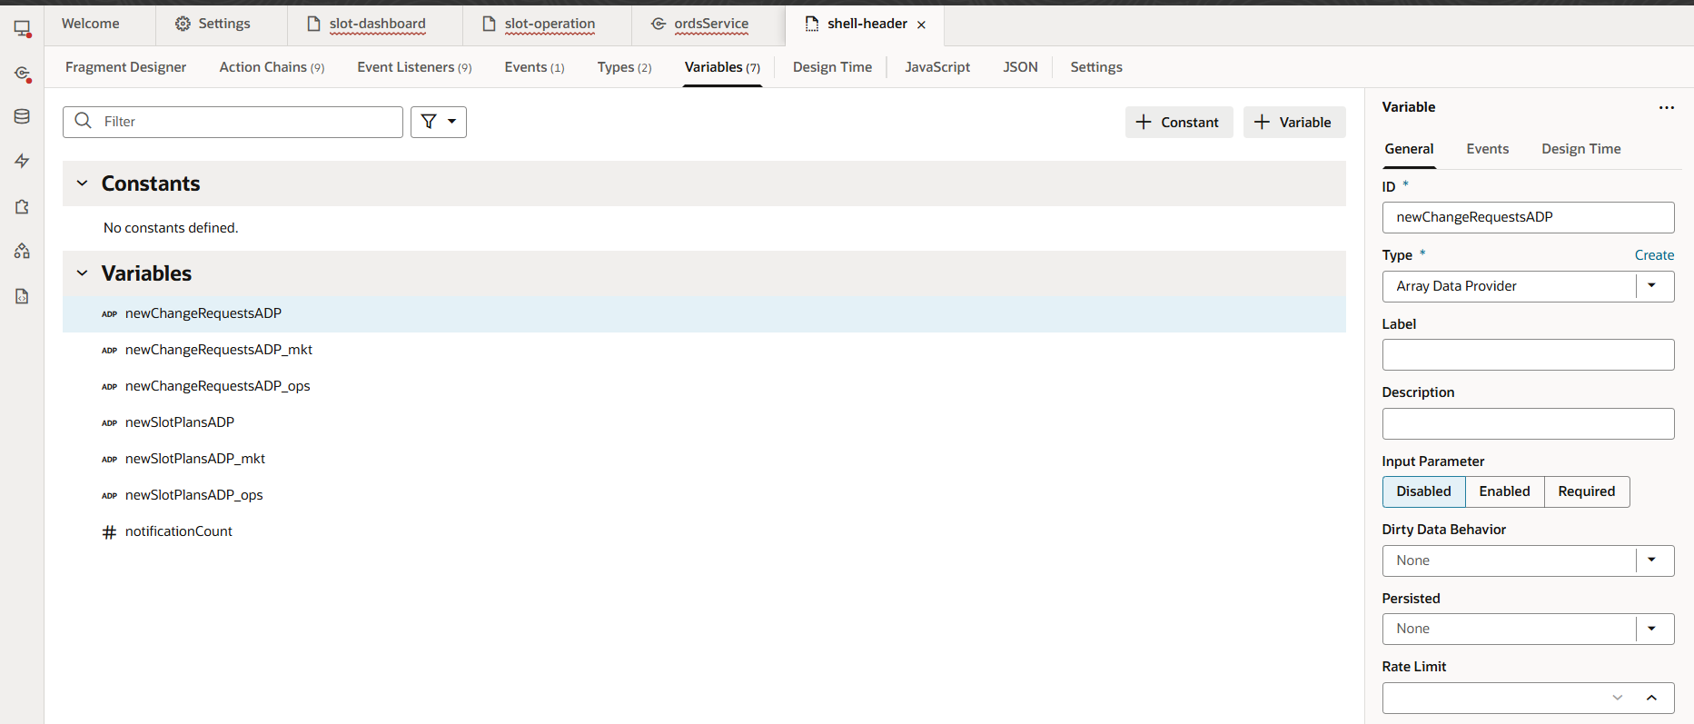
variable:
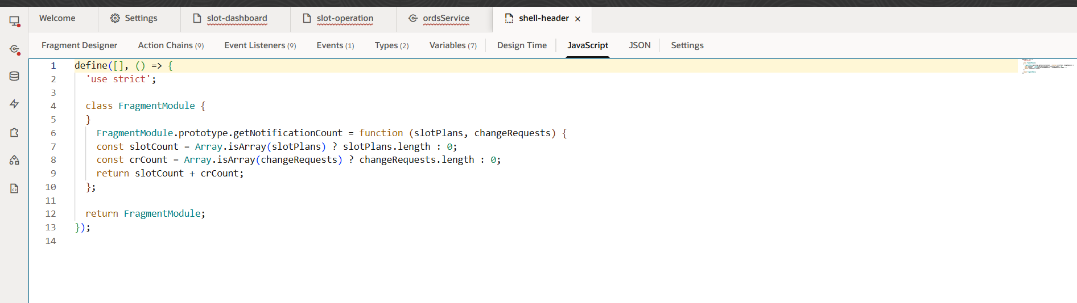

JavaScript:
define([], () => {
'use strict';

class FragmentModule {
}
FragmentModule.prototype.getNotificationCount = function (slotPlans, changeRequests) {
const slotCount = Array.isArray(slotPlans) ? slotPlans.length : 0;
const crCount = Array.isArray(changeRequests) ? changeRequests.length : 0;
return slotCount + crCount;
};

return FragmentModule;
});

Step 2: we cannot be able to navigate to the page which is in the main flow
For that we need to make some changes in the code.

- Create a event for the navigation in the fragment tab.
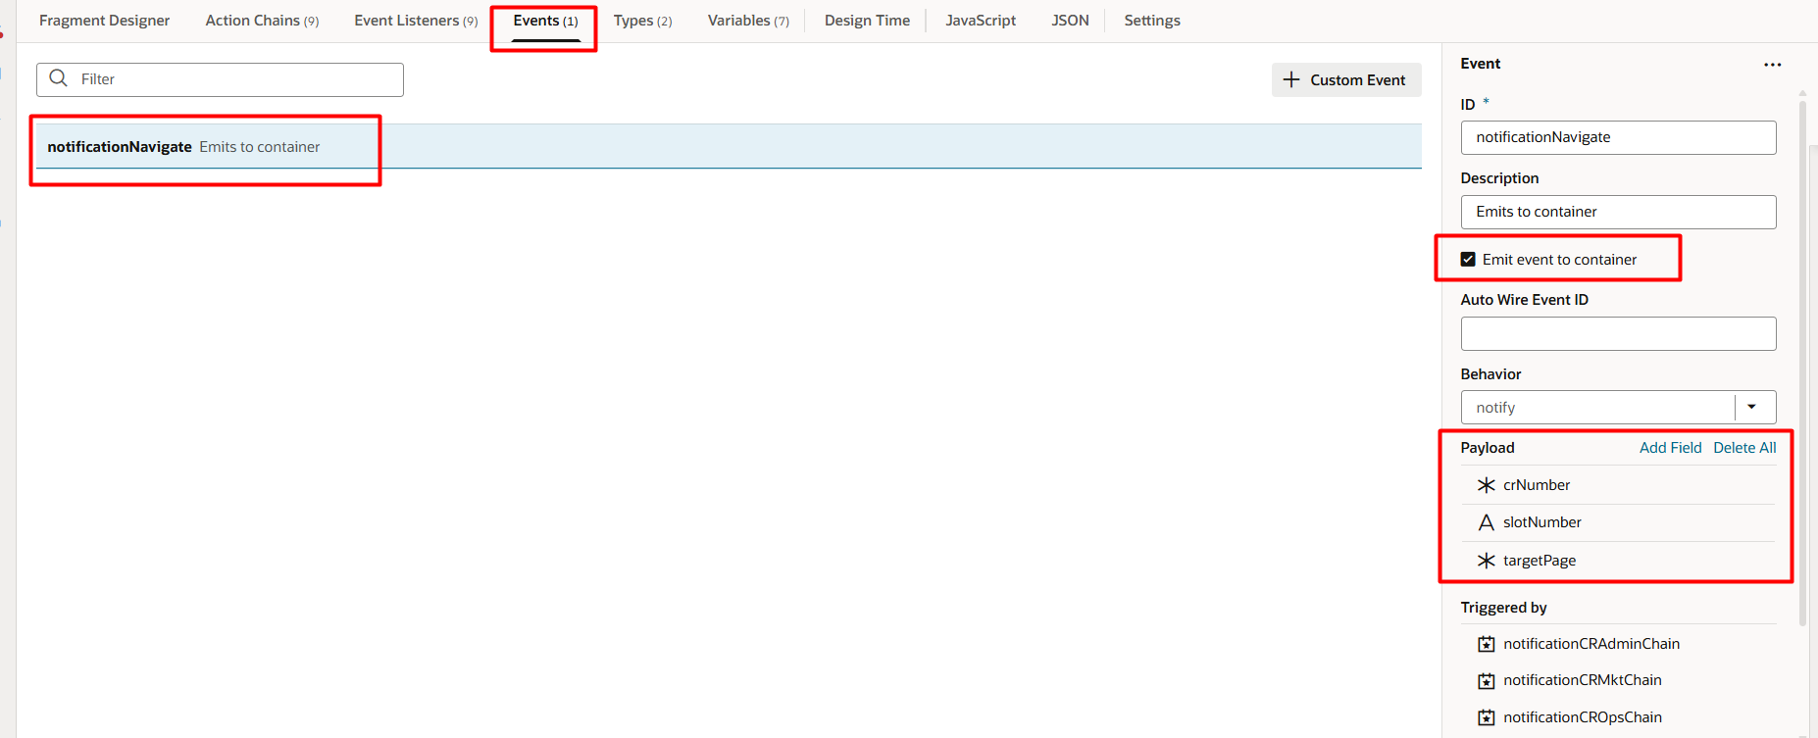
for the payload
add the “targetpage”(any variable) parameter – this is used to get the name of the page which you want to navigate.
if you want to add the parameters for the page we need to create a variable and use the variable to access it in the page to navigate.
- Use the “fire Event” to navigate to the page.
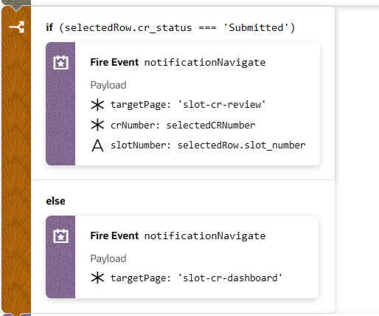

- Select the fragment and then add the “event listner”
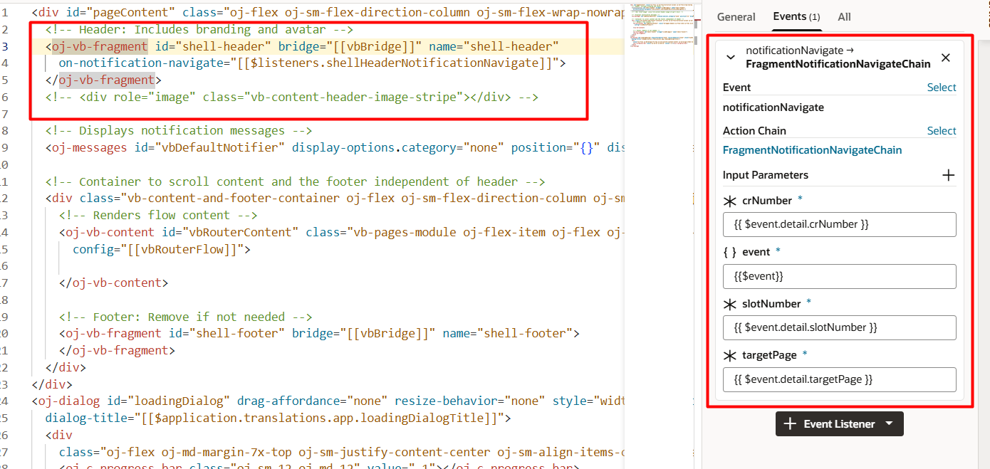

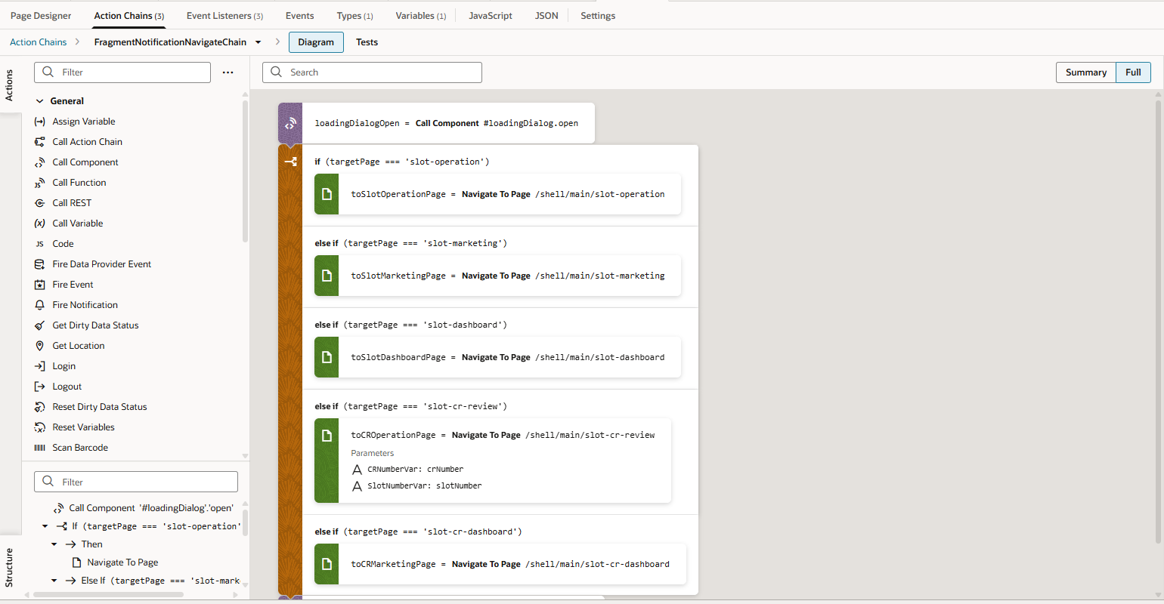

When the target page is “slot-cr-review” it will navigate to the cr review page same like this we have done it for all the changes.

